Used Book Sharing System

UI Prototype

Version 1.1

Revision History

|  |  |  |  |
| --- | --- | --- | --- |
| **Date** | **Version** | **Description** | **Author** |
| 08/12/2019 | 1.0 | Initial document | Dang Duc Trung |
| 09/12/2019 | 1.1 | Edit document | Dang Duc Trung |

**Main Screen**

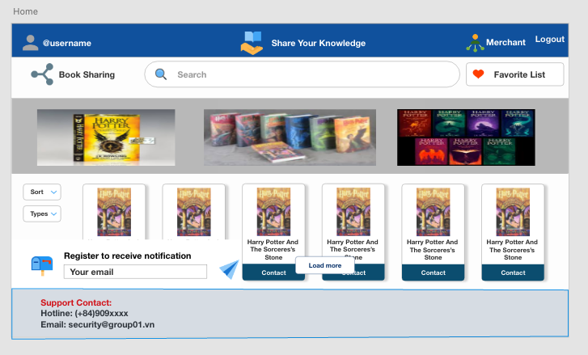

* Purpose: Homepage provide for user can use general function of website.

1. **Book Detail Screen**

* In homepage when user click to book will lead to Book Detail Screen.
* Purpose: Provide for user about book’s information and merchant who uploaded this book. Reader can comment and rate about merchant or book in this window.

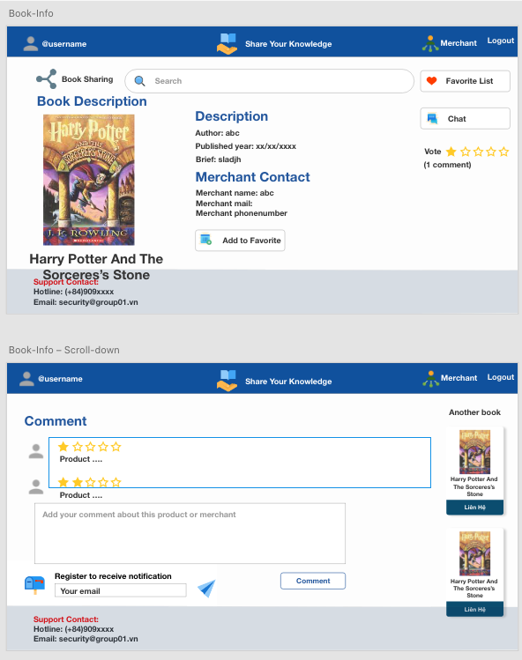

**1.1 Favorite List View**

* In Detail View if user click Favorite List button will lead to Favorite List View.
* Purpose: Contain all books which was liked by user and intend to buy in future.

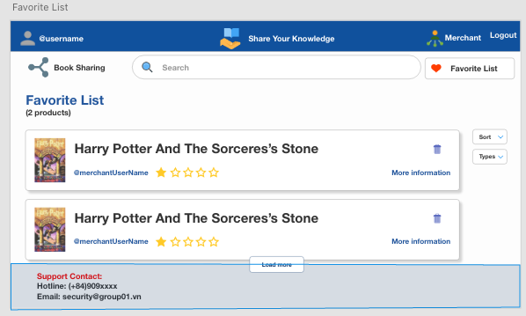

**1.2 Chat View**

* In Detail View if user click to Chat button will lead to Chat View.
* Purpose: Provide tool for reader can chat with merchant and vice versa.

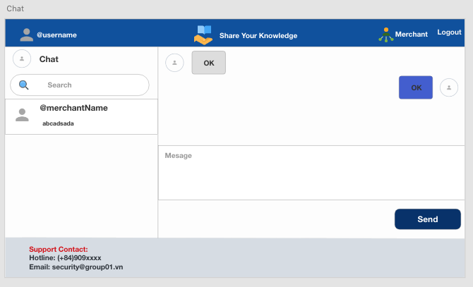

1. **Book Search Screen**

* In homepage if user fill text in search textfield system will respond filtered result.
* Purpose: User can easy choose agreeably book.

**2.1 In case user is merchant or reader**

**2.1.1 Have book screen**

* If book related information is have in database will lead to this screen.

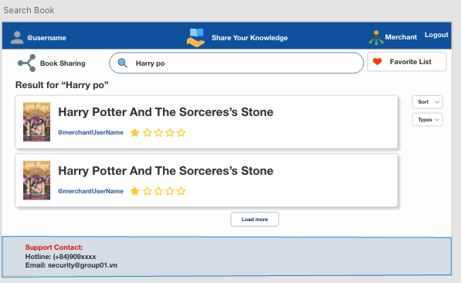

**2.1.2 Don’t have book screen**

* If book related information isn’t have in database will lead to this screen.

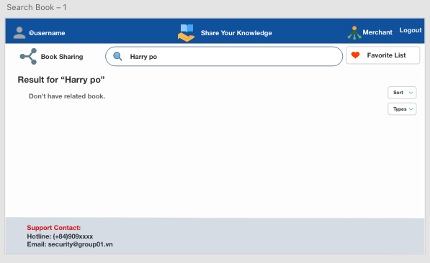

**2.2 In case user is admin**

**2.2.1 Have book screen**

* + If book related information is have in database will lead to this screen.
  + Purpose: Admin can find and delete book which is illegal.

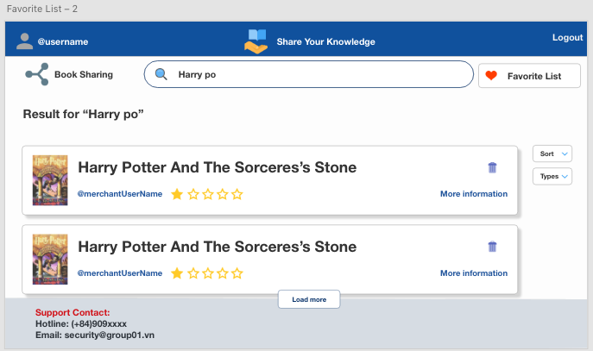

**2.1.2 Don’t have book screen**

* + If book related information isn’t have in database will lead to this screen.

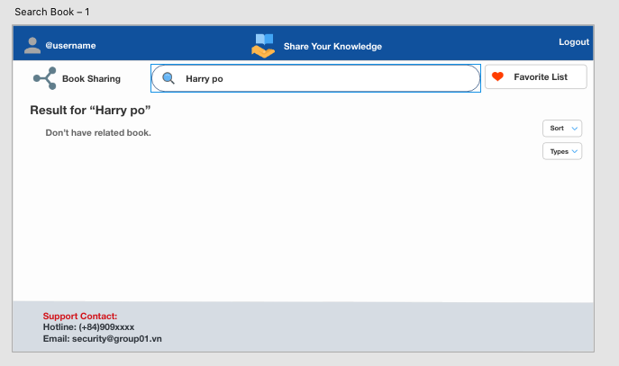

1. **Upload Book View**

* In homepage when merchant click to icon Merchant in navbar will lead to this screen.
* Purpose: Merchant use this screen to fill information about book which he/she want to sell.

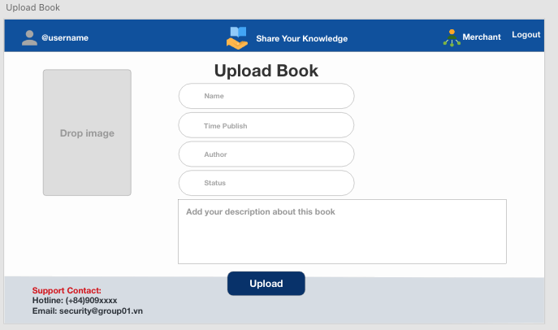

**3.1 Fill not enough information**

* Purpose: Notice for merchant need to fill all information about book.

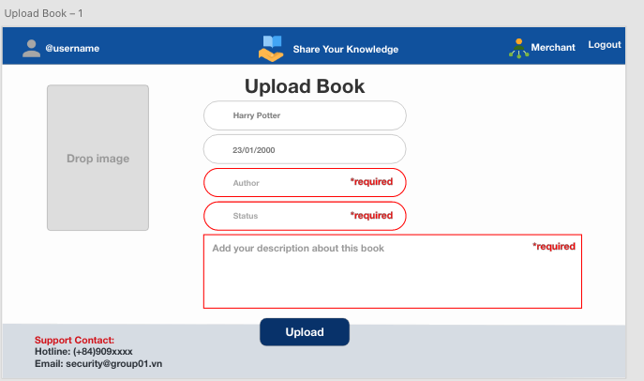

**3.2 All information is valid and upload book successful**

* Purpose: Notice for merchant know about uploading book status.

